
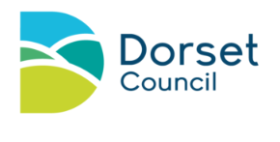
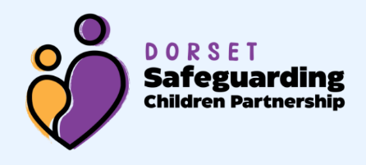

If you are concerned about the safety or well being of a child:

In Dorset
Call: Children’s Advice and Duty Service (ChAD) on: 01305 228866
Call: Family Support and Advice Line on: 01305 228558
Call: Out of hours emergencies on: 01305 221000

In Bournemouth, Christchurch, Pool (BCP)
Call: Children’s First Response Hub Telephone: 01202 123334
Email: childrensfirstresponse@bcpcouncil.gov.uk
Call: Out of hours emergencies on: 01202 738256 Email: childrensOOHS@bcpcouncil.gov.uk

Police non-emergency 101 / emergency 999

If you need support or advice about your family or situation:

Dorset Contact: The Early Help Family Support Teams
Locality information: https://dorsetcouncil.gov.uk/children-families/worried-about-a-child
BCP Contact: The Early Help Access Point here

If you have concerns regarding an adult who works with children:

Contact Dorset LADO
Call: 01305 221122
Email: LADO@dorsetcouncil.gov.uk
Online form: Referral form

BCP (Bournemouth, Christchurch, Pool) LADO
Call: 01202 817600
Email: LADO@bcpcouncil.gov.uk
Online form: Referral form

